False positives
- No changes requried - table created with file name but then use alter rename with new table name
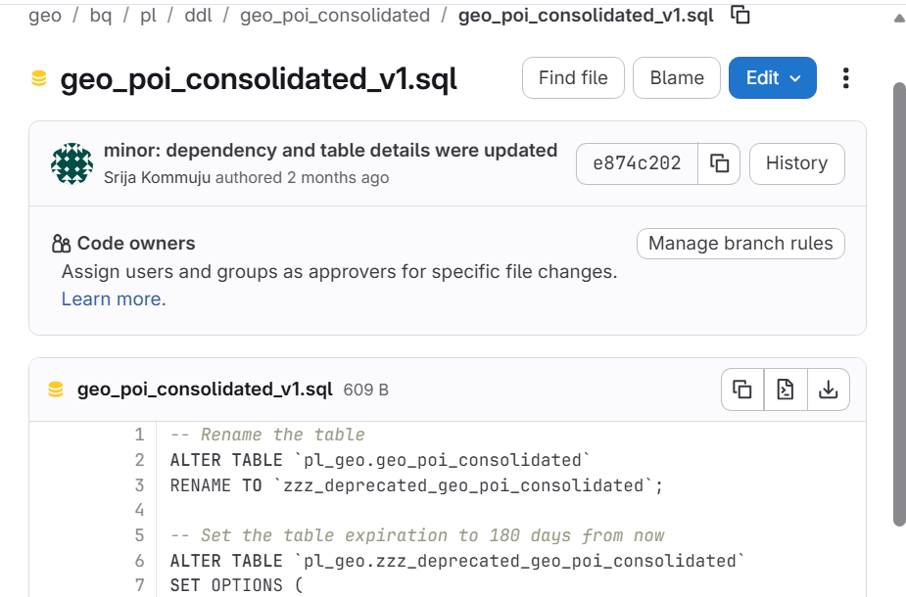
- Source view definition and selected GCP view definition differ after normalization.
  - CREATE VIEW ... AS
  - View column list (devname, part_function)
  - Comments (--)
  - Extra semicolons (;)
  - Extra spaces

- Object exists in the selected source snapshot but not in the selected GCP dataset inventory. source_kind=dbt_model

DBT Models starting with Merge_xxx names getting dropped using drop statements.

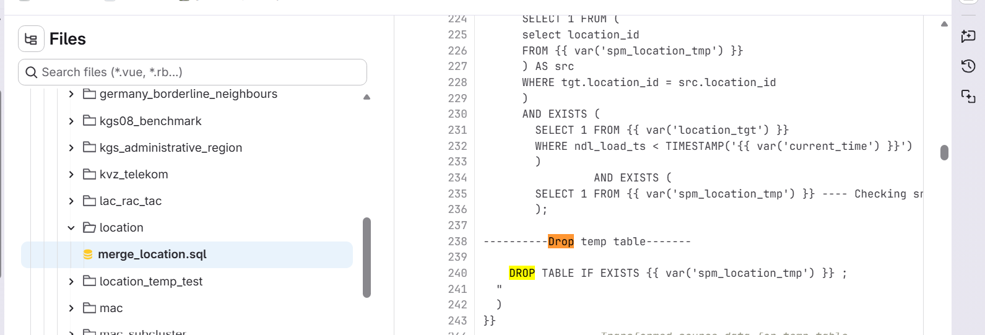

Multiple tables getting created from one DDL script.

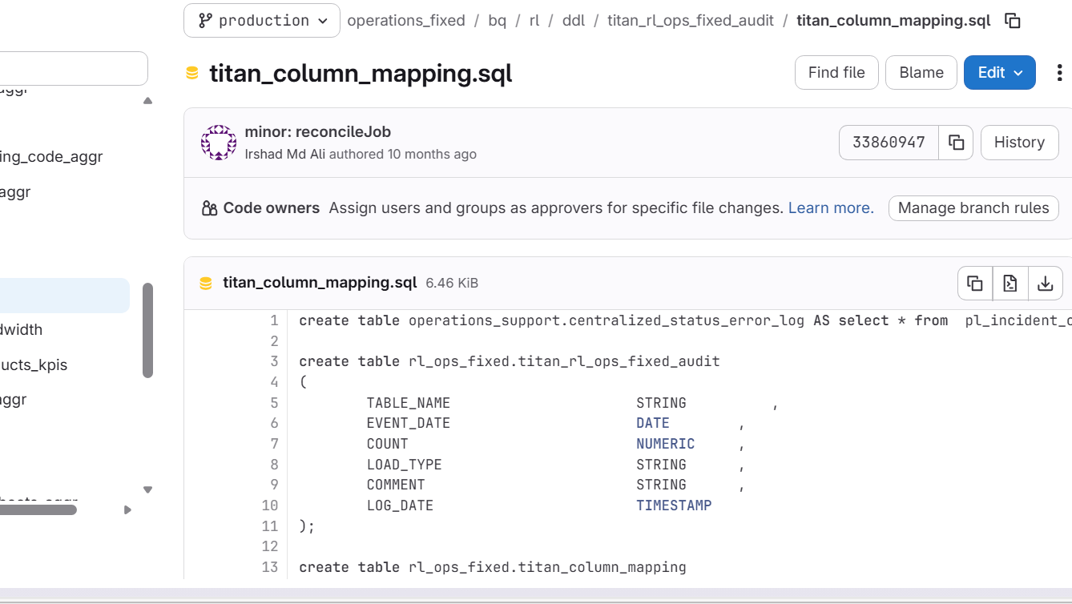

Naming conventions issue like datasetname.objectname.sql

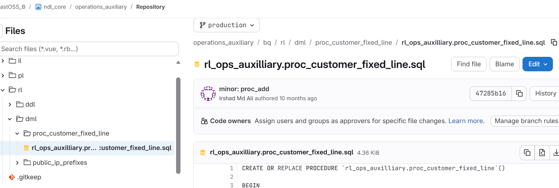

Objects ending with agger mostly merging the data into another table.

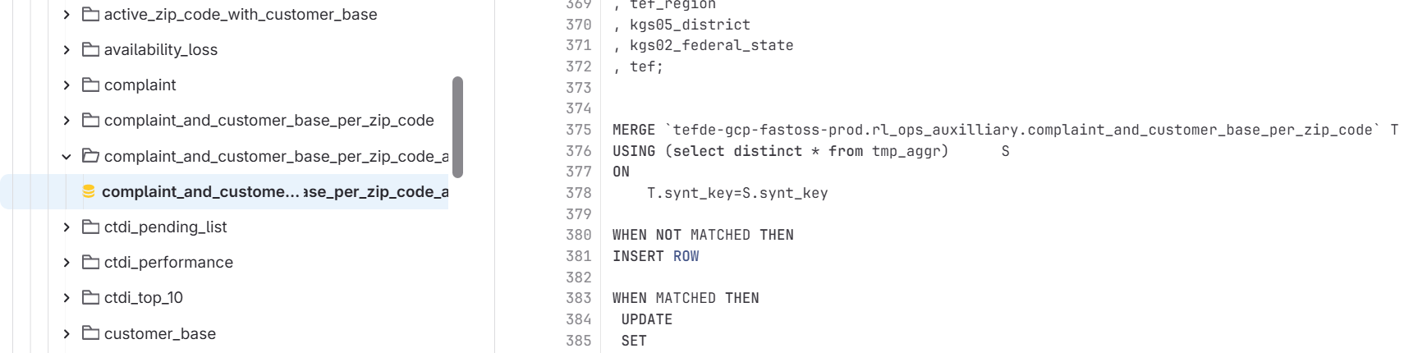

- Statement: missing_in_prod=[]; extra_in_prod=[]; type_mismatch=['municipality_population_rank']

Actual DDL:
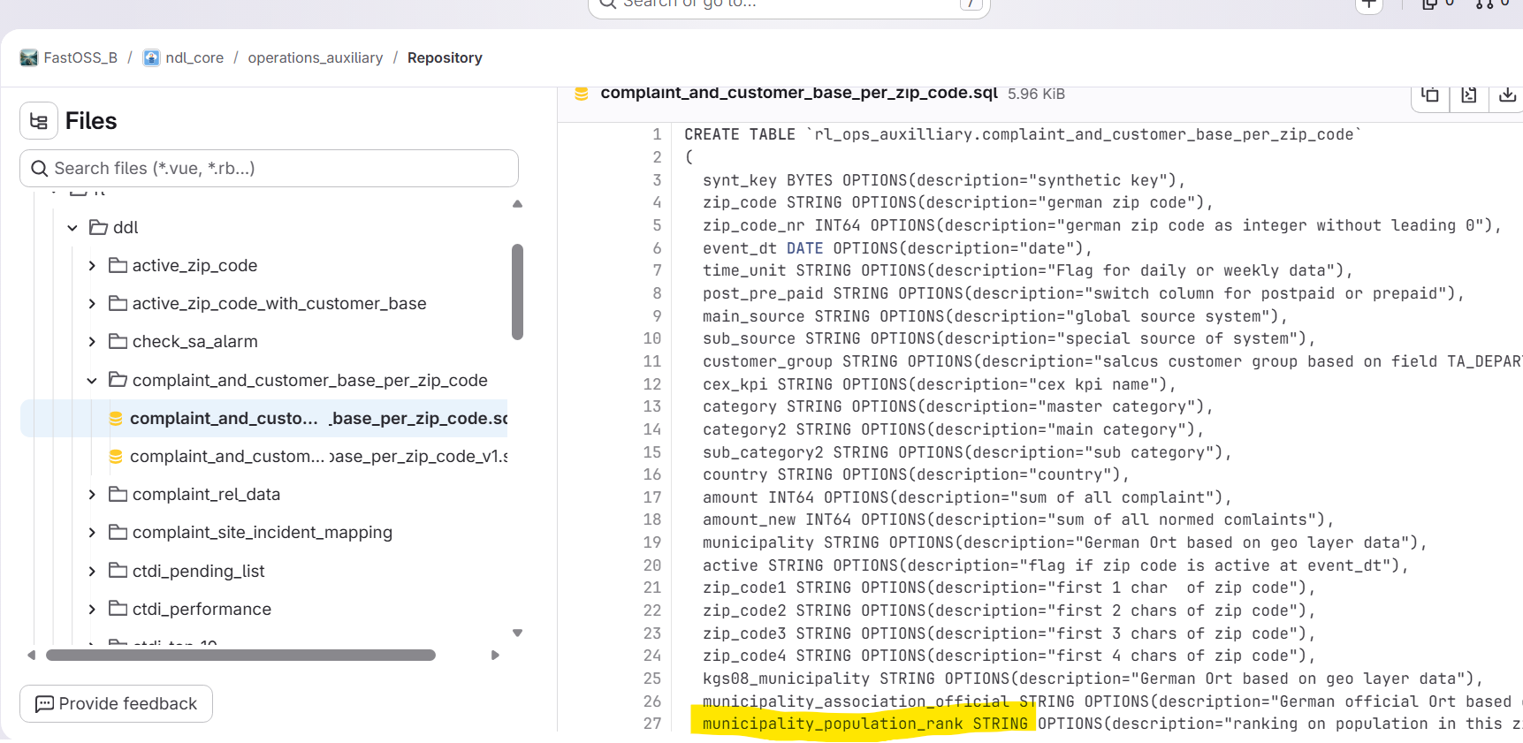

V1 DDL:
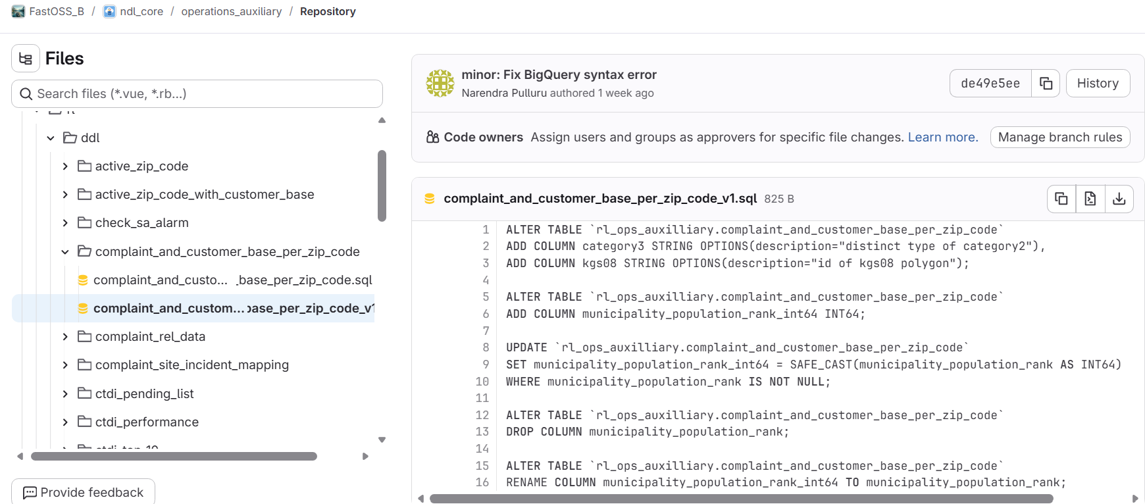
From above screenshots, there are two versions, initially in 1st version the type is string. But in v1 the datatype got corrected. But Report is not identifying this issue.

